# React HandsOn - 9

ListOfPlayers.js

import React from 'react';

const ListofPlayers = () => {

const players = [

{ name: 'Virat', score: 95 },

{ name: 'Rohit', score: 88 },

{ name: 'Dhoni', score: 60 },

{ name: 'Rahul', score: 45 },

{ name: 'Jadeja', score: 80 },

{ name: 'Bumrah', score: 77 },

{ name: 'Shami', score: 66 },

{ name: 'Surya', score: 100 },

{ name: 'Gill', score: 92 },

{ name: 'Pant', score: 58 },

{ name: 'Ashwin', score: 72 },

];

const filteredPlayers = players.filter(player => player.score < 70);

return (

<>

<h2>All Players</h2>

<ul>

{players.map((player, idx) => (

<li key={idx}>Mr. {player.name} <span>{player.score}</span></li>

))}

</ul>

<h2>Players with score below 70</h2>

<ul>

{filteredPlayers.map((player, idx) => (

<li key={idx}>{player.name} - {player.score}</li>

))}

</ul>

</>

);

};

export default ListofPlayers;

IndianPlayers.js

import React from 'react';

export function OddPlayers([first, third, fifth]) {

return (

<div>

<h3>Odd Team Players</h3>

<ul>

<li>First: {first}</li>

<li>Third: {third}</li>

<li>Fifth: {fifth}</li>

</ul>

</div>

);

}

const T20Players = ['FirstPlayer', 'SecondPlayer', 'ThirdPlayer'];

const RanjiTrophyPlayers = ['FourthPlayer', 'FifthPlayer', 'SixthPlayer'];

export const IndianPlayers = [...T20Players, ...RanjiTrophyPlayers];

export const IndianPlayersComponent = () => {

const evenPlayers = IndianPlayers.filter((_, i) => i % 2 === 1);

const oddPlayers = IndianPlayers.filter((_, i) => i % 2 === 0);

return (

<>

<OddPlayers {...[oddPlayers]} />

<h3>Even Team Players</h3>

<ul>

{evenPlayers.map((player, idx) => <li key={idx}>{player}</li>)}

</ul>

<h3>Merged Players List</h3>

<ul>

{IndianPlayers.map((player, idx) => <li key={idx}>{player}</li>)}

</ul>

</>

);

};

App.js

import React from 'react';

import ListofPlayers from './ListofPlayers';

import { IndianPlayersComponent } from './IndianPlayers';

function App() {

const flag = true; // Change to false to test IndianPlayers

return (

<div className="App">

<h1>Cricket App</h1>

{flag ? <ListofPlayers /> : <IndianPlayersComponent />}

</div>

);

}

export default App;

Output:

When flag true:  
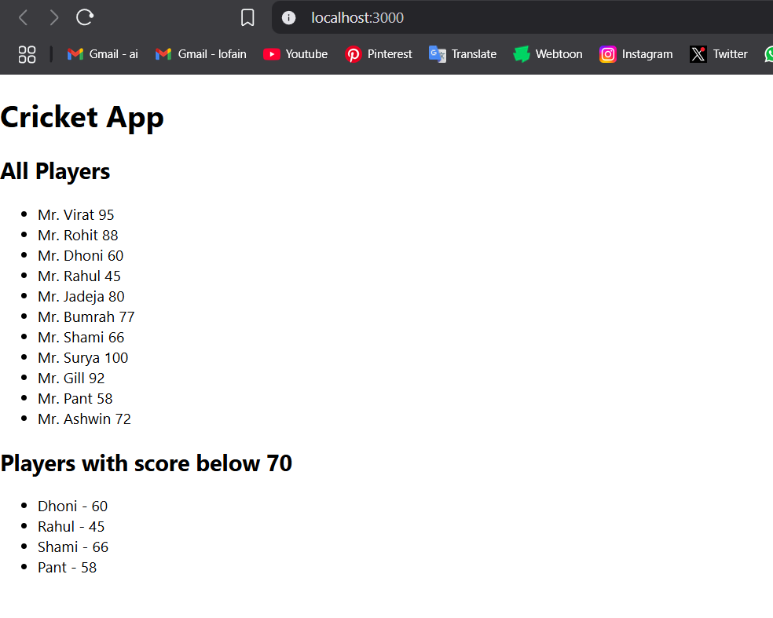

When flag false:

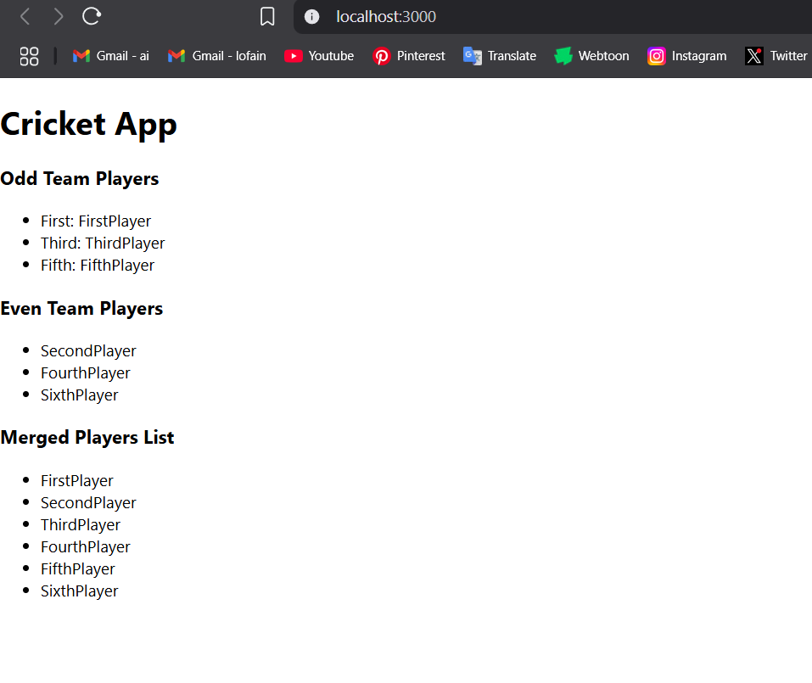

# React HandsOn - 10

App.js

import React from 'react';

function App() {

const officeList = [

{

id: 1,

name: "Downtown Hub",

rent: 45000,

address: "123 Main Street, Chennai",

image: "/dt-hub.png"

},

{

id: 2,

name: "Skyview Towers",

rent: 85000,

address: "456 Skyline Blvd, Bangalore",

image: "/skyview-towers.png"

},

{

id: 3,

name: "GreenSpace Offices",

rent: 62000,

address: "789 Eco Lane, Hyderabad",

image: "/greenspace-offices.png"

}

];

return (

<div style={{ padding: '20px', fontFamily: 'Arial' }}>

<h1>🏢 Office Space Rental App</h1>

<div style={{ display: 'flex', gap: '20px', flexWrap: 'wrap' }}>

{officeList.map(office => (

<div key={office.id} style={{ border: '1px solid #ccc', margin: '20px 0', padding: '15px', borderRadius: '8px' }}>

<h2>{office.name}</h2>

<img src={office.image} alt={office.name} width="300" />

<p><strong>Address:</strong> {office.address}</p>

<p>

<strong>Rent:</strong>{' '}

<span style={{ color: office.rent < 60000 ? 'red' : 'green' }}>

₹{office.rent}

</span>

</p>

</div>

))}

</div>

</div>

);

}

export default App;

Ouput:  
  
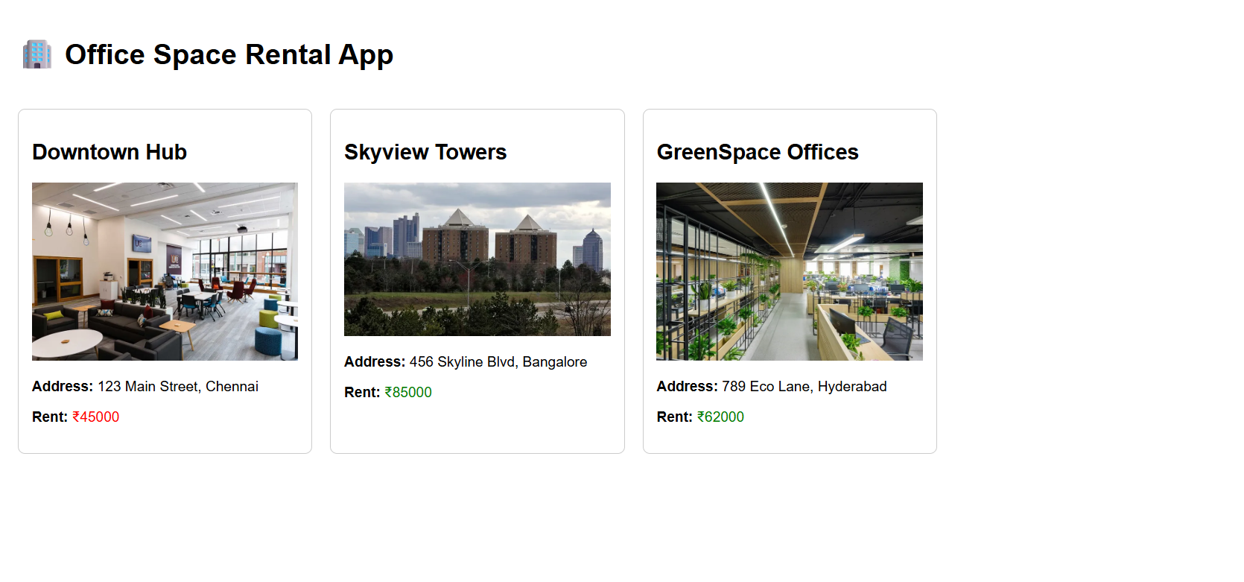

# React HandsOn - 11

App.js

import React, { useState } from 'react';

import CurrencyConvertor from './CurrencyConverter';

function App() {

const [count, setCount] = useState(0);

const increment = () => {

setCount(prev => prev + 1);

sayHello();

showMessage();

};

const decrement = () => setCount(prev => prev - 1);

const sayHello = () => {

console.log("Hello!");

};

const showMessage = () => {

console.log("This is a static message.");

};

const sayWelcome = (msg) => {

alert(msg);

};

const onPressHandler = () => {

alert("I was clicked");

};

return (

<div style={{ padding: "20px" }}>

<h1>Event Examples App</h1>

<h2>Counter: {count}</h2>

<button onClick={increment}>Increment</button>

<button onClick={decrement}>Decrement</button>

<br /><br />

<button onClick={() => sayWelcome("Welcome!")}>Say Welcome</button>

<br /><br />

<button onClick={onPressHandler}>OnPress</button>

<br /><br />

<CurrencyConvertor />

</div>

);

}

export default App;

CurrencyConvertor.js

import React, { useState } from 'react';

function CurrencyConvertor() {

const [rupees, setRupees] = useState('');

const [euro, setEuro] = useState(null);

const handleSubmit = () => {

const converted = (parseFloat(rupees) / 88.5).toFixed(2);

setEuro(converted);

};

return (

<div>

<h2>Currency Convertor</h2>

<input

type="number"

placeholder="Enter amount in INR"

value={rupees}

onChange={(e) => setRupees(e.target.value)}

/>

<button onClick={handleSubmit}>Convert</button>

{euro && <p>€ {euro}</p>}

</div>

);

}

export default CurrencyConvertor;

Output:

Increment & Decrement

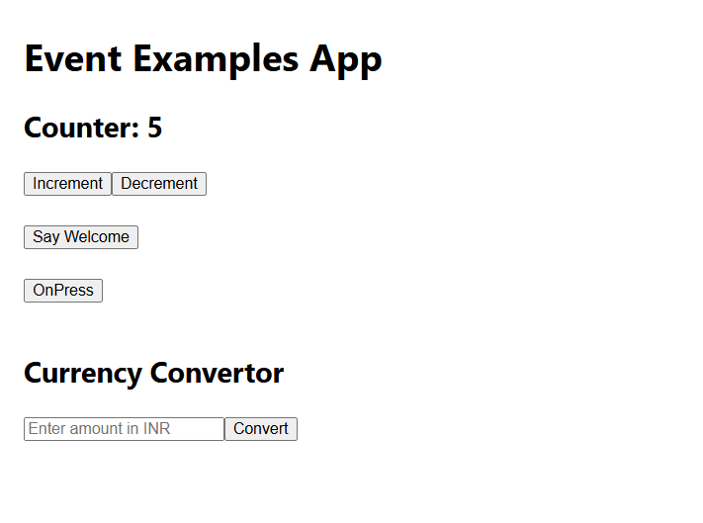

Say Welcome:

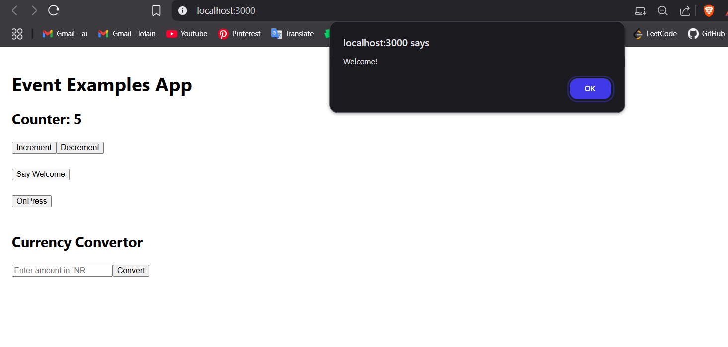  
OnPress

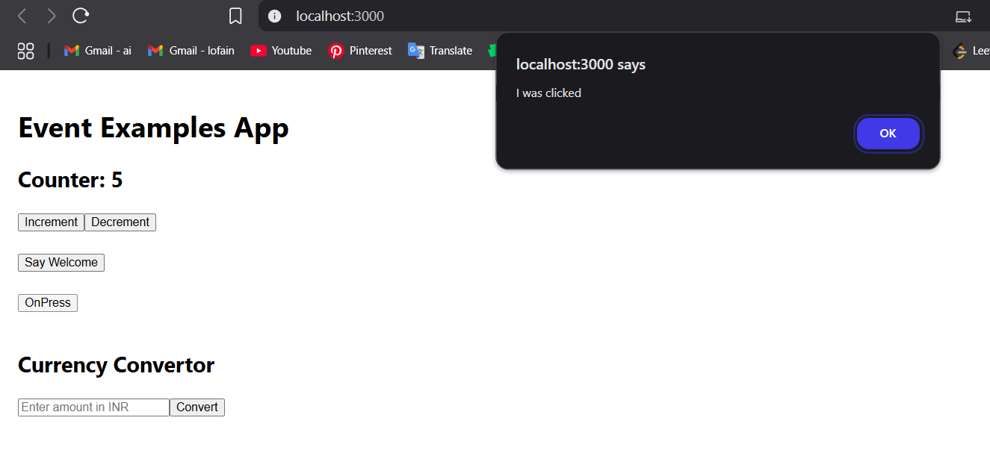

CurrencyConvertor

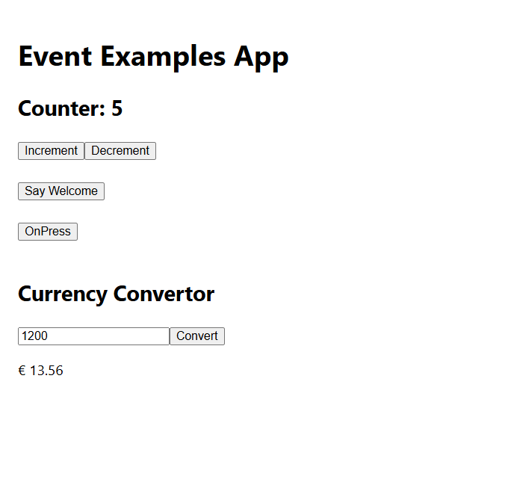

# React HandsOn - 12

App.js

import React, { useState } from 'react';

import GuestPage from './components/GuestPage';

import UserPage from './components/UserPage';

const App = () => {

const [isLoggedIn, setIsLoggedIn] = useState(false);

const handleLogin = () => setIsLoggedIn(true);

const handleLogout = () => setIsLoggedIn(false);

return (

<div>

<h1>✈️ Ticket Booking App</h1>

{isLoggedIn ? (

<>

<UserPage />

<button onClick={handleLogout}>Logout</button>

</>

) : (

<>

<GuestPage />

<button onClick={handleLogin}>Login</button>

</>

)}

</div>

);

};

export default App;

GuestPage.js

import React from 'react';

import FlightList from './FlightList';

const GuestPage = () => {

return (

<div>

<h2>Welcome Guest</h2>

<p>You can only view the flight details.</p>

<FlightList />

</div>

);

};

export default GuestPage;

UserPage.js

import React from 'react';

import FlightList from './FlightList';

const UserPage = () => {

return (

<div>

<h2>Welcome User</h2>

<FlightList showBooking={true} />

</div>

);

};

export default UserPage;

FlightList.js

import React from 'react';

const flights = [

{ id: 1, from: "Chennai", to: "Delhi", price: 4500 },

{ id: 2, from: "Mumbai", to: "Kolkata", price: 5000 },

{ id: 3, from: "Bangalore", to: "Hyderabad", price: 3000 },

];

const FlightList = ({ showBooking = false }) => {

return (

<div>

<h3>Flight Details</h3>

<ul>

{flights.map(flight => (

<li key={flight.id}>

{flight.from} ➝ {flight.to} - ₹{flight.price}

{showBooking && <button style={{ marginLeft: '10px' }}>Book</button>}

</li>

))}

</ul>

</div>

);

};

export default FlightList;

Output:

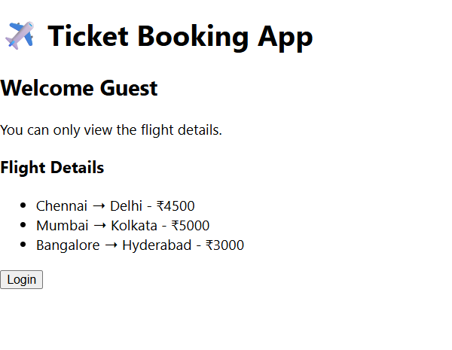

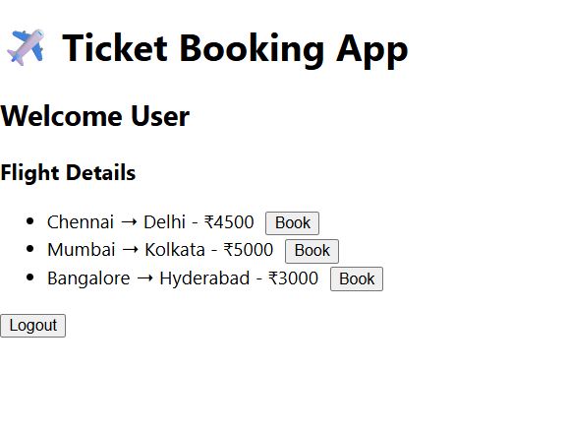

# React HandsOn - 13

App.js

import React, { useState } from "react";

import BookDetails from "./BookDetails";

import BlogDetails from "./BlogDetails";

import CourseDetails from "./CourseDetails";

function App() {

const [show, setShow] = useState("book");

const renderComponent = () => {

if (show === "book") return <BookDetails />;

else if (show === "blog") return <BlogDetails />;

else return <CourseDetails />;

};

return (

<div>

<h1>Blogger App</h1>

{show === "book" && <p>Currently viewing Book Details</p>}

{/* Using Ternary Operator */}

{show === "blog" ? <p>Viewing Blog Details</p> : <p>Not viewing Blog</p>}

{/* Using Element Variables */}

{renderComponent()}

<button onClick={() => setShow("book")}>Book</button>

<button onClick={() => setShow("blog")}>Blog</button>

<button onClick={() => setShow("course")}>Course</button>

</div>

);

}

export default App;

BookDetails.js

function BookDetails() {

return <h2>Book: "React Explained"</h2>;

}

export default BookDetails;

BlogDetails.js

function BlogDetails() {

return <h2>Blog: "React Tips & Tricks"</h2>;

}

export default BlogDetails;

CourseDetails.js

function CourseDetails() {

return <h2>Course: "Full Stack Web Development"</h2>;

}

export default CourseDetails;

Output:

